ACH Payments

An Overview

3/17/2014

Capgemini

Praveen V

Table of Contents

1. ACH Payment 3

1. Automated Clearing House (ACH 3

2. Illustrations of ACH Payments 3

3. How to know if a transaction is an ACH Credit or ACH Debit 3

4. ACH Work Flow: 3

5. Participants in ACH Payments:- 4

6. Illustrations of ACH Payments in day to day life:- 5

7. ACH Credit 5

8. ACH Debit 5

9. ACH Transfers Credit 6

10. ACH Transfers Debit 6

2. ACH Payment in HSBCnet 7

Different Type of ACH Payment Instructions: 7

1. ACH Credits 7

2. ACH Debits 8

3. ACH Transfers Credit 9

4. ACH Transfers Debit 10

ACH Payment

Automated Clearing House (ACH) is an electronic network for financial transactions in the United States. ACH processes large volumes of credit and debit transactions in batches.

**ACH payments** are electronic payments made through the Automated Clearing House ([ACH](/od/checkingaccounts/g/ach.htm)) Network. Using ACH payments can help reduce errors, speed things up, and save resources.

## **Illustrations of ACH Payments**:-

* Direct Deposit of payroll, Social Security and other government benefits, and tax refunds
* Direct Payment of consumer bills as mortgages, loans, utility bills, and insurance premiums
* Business-to-business payments
* E-Commerce payments
* Federal, state, and local payments

## How to know if a transaction is an ACH Credit or ACH Debit

* In ACH terminology, Originator and Receiver refer to the participants that initiate and receive the ACH entries rather than the funds.
* ACH entry may either be a credit or debit entry. By examining what happens to the Receiver's account, one can distinguish the difference between an ACH credit and an ACH debit transaction.
* If the Receiver's account is debited, then the entry is an ACH debit.
* If the Receiver's account is credited, then the entry is an ACH credit.
* Conversely, the offset to an ACH debit is a credit to the Originator's account and the offset to an ACH credit is a debit of the Originator's account.

## ACH Work Flow:

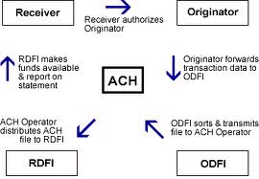

## Participants in ACH Payments:-

1. **ODFI (Originating Depository Financial Institution)**

A participating financial institution that originates ACH entries at the request of and by (ODFI) agreement with its customers is known as ODFI.

ODFI's must abide by the provisions of The NACHA (National Automated Clearing House Association) Operating Rules.

1. **Originator**

The Originator can be any individual, corporation or other entity that initiates entries into the Automated Clearing House Network.

1. **RDFI (Receiving Depository Financial Institution)**

Any financial institution qualified to receive ACH entries that agree to abide by the *NACHA Operating Rules.*

1. **Receiver**

The Receiver can be any individual, corporation or other entity that has authorized an Originator to initiate a credit or debit entry to a transaction account held at an RDFI.

1. **ACH Operators**

The Federal Reserve and Electronic Payments Network act as ACH Operators, central clearing facilities through which financial institutions transmit or receive ACH entries.

1. **Third-Party Service Providers**

A Third-Party Service Provider is an entity other than the Originator, ODFI, or RDFI that performs any function on behalf of the Originator, ODFI, or RDFI with respect to the processing of ACH entries.

Example: Western Union money transfer service.

## Illustrations of ACH Payments in day to day life:-

* If a person go into a sports shop and purchase a pair of runners for $70 you could write a check for this amount. By writing this check you are the receiver and you are giving the originator permission to withdraw money from your account. You give the permission to do this by signing the check.
* A corporate employer offering its employees direct deposit of payroll will be originator and employees will be the receivers by giving employer permission to put the salaries into their accounts.

## **ACH Credit**

ACH Credit instructions involve one debit to the user’s account and multiple credits to beneficiaries.

Example ofACH credit transfers includes [direct deposit](/wiki/Direct_deposit?qsrc=3044) payroll and vendor payments.

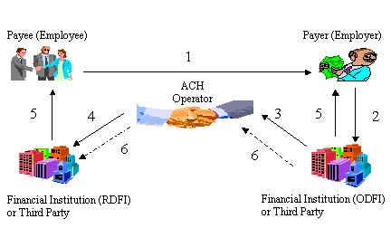

**ACH Credit clearing and settlement flow**

Step1:- The payee authorizes an employer to deposit his or her paycheck through direct deposit.

Step2:- The employer submits its direct deposit payroll ACH files to the ODFI.

Step3:- The ODFI verifies the files and submits them through the corresponding ACH operator.

Step4:- The ACH operator routes the transaction to the payee's financial institution (RDFI).

Step5:- The RDFI makes the funds available to the payee by crediting his or her account.

Step6:- The ACH operator settles the transaction between the participating financial institutions.

### ACH Debit

ACH Debitinstructions involve one credit to the user’s account and debits to multiple payor account.

Examples ofACH [direct debit](/wiki/Direct_debit?qsrc=3044) transfers are include consumer payments on insurance premiums, [mortgage loans](/wiki/Mortgage_loans?qsrc=3044), and other kinds of bills.

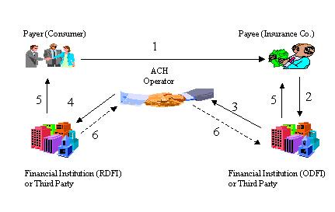

**ACH Debit clearing and settlement flow**

Step1:- The payer sends the ACH payment information and authorization to the payee (insurance company).

Step2:- The payee submits this information to its financial institution (ODFI).

Step3:- Financial institution routes the transaction to an ACH operator.

Step4:- The ACH operator routes the transaction to the receiving financial institution.

Step5:- Funds are made available to the payee and the payer's account is debited.

Step6:- The ACH operator settles the transactions between the participating financial institutions.

### ACH Transfers Credit

ACH Transfers Credit instruction involves:-

* One debit to the user’s account and multiple credits to the other accounts of the same user within their HSBCnet portfolio of accounts.
* ACH Transfer Credit service is available only to US account holders.
* Examples of an ACH Transfer Credit are transfers from the head office account to branch accounts of a company.

### ACH Transfers Debit

ACH Transfers Debit instructions involves:-

* One credit to the user’s account and multiple debits to the other accounts of the same user within their HSBCnet portfolio of accounts.
* ACH Transfer Debit service is available only to US account holders.
* Examples of an ACH Transfer Debit are transfers from the branch account to head office account of a company.

# ACH Payment in HSBCnet

**ACH (Automated Clearing house) instructions** are typically high-volume, low-value batch instructions used to make payments or collections from or to a single account.

ACH payments are issued in domestic currency and are processed within the local clearing system.

## Different Type of ACH Payment Instructions:

* **ACH Credits.**
* **ACH Debits.**
* **ACH Transfer Credit.**
* **ACH Transfer Debit.**

## ACH Credits

* **ACH Credit** instructions involve one debit to the user’s account and multiple credits to beneficiaries.
* Example ofACH credit transfers includes [direct deposit](/wiki/Direct_deposit?qsrc=3044) payroll, interest and dividend payments.

**Example: ACH Credit instruction**

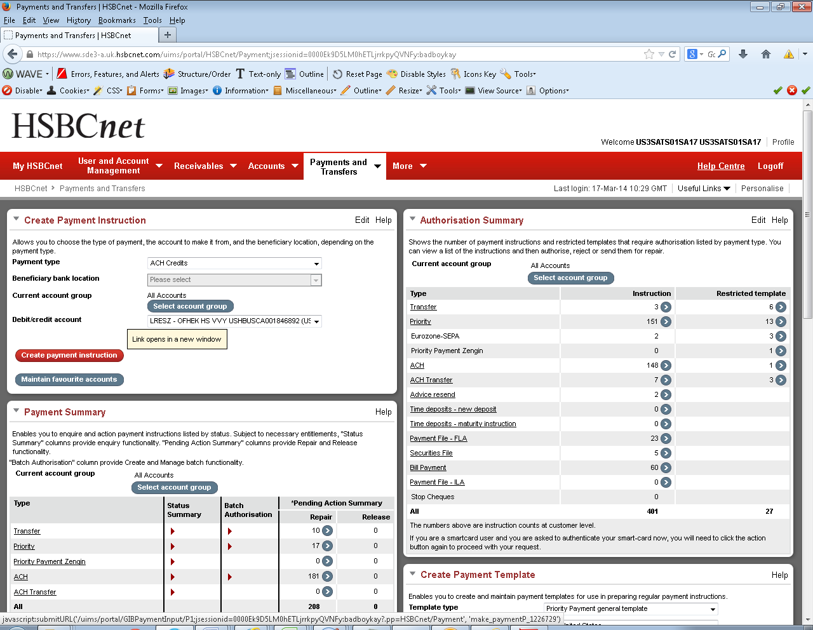

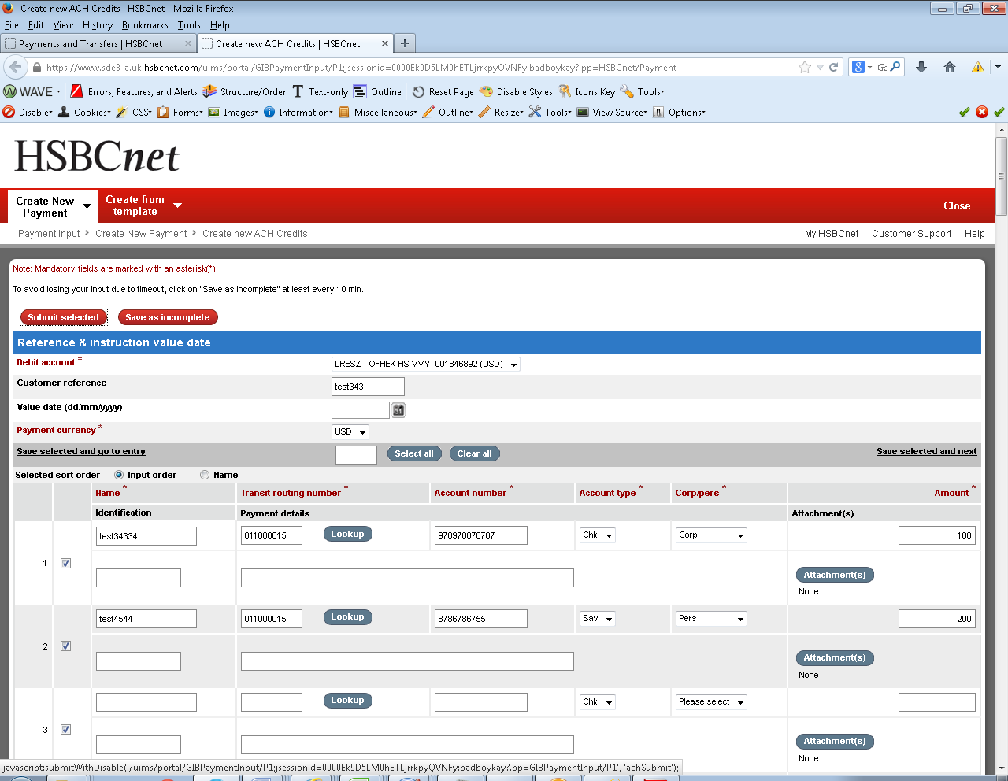

**For standing instruction creation:-**

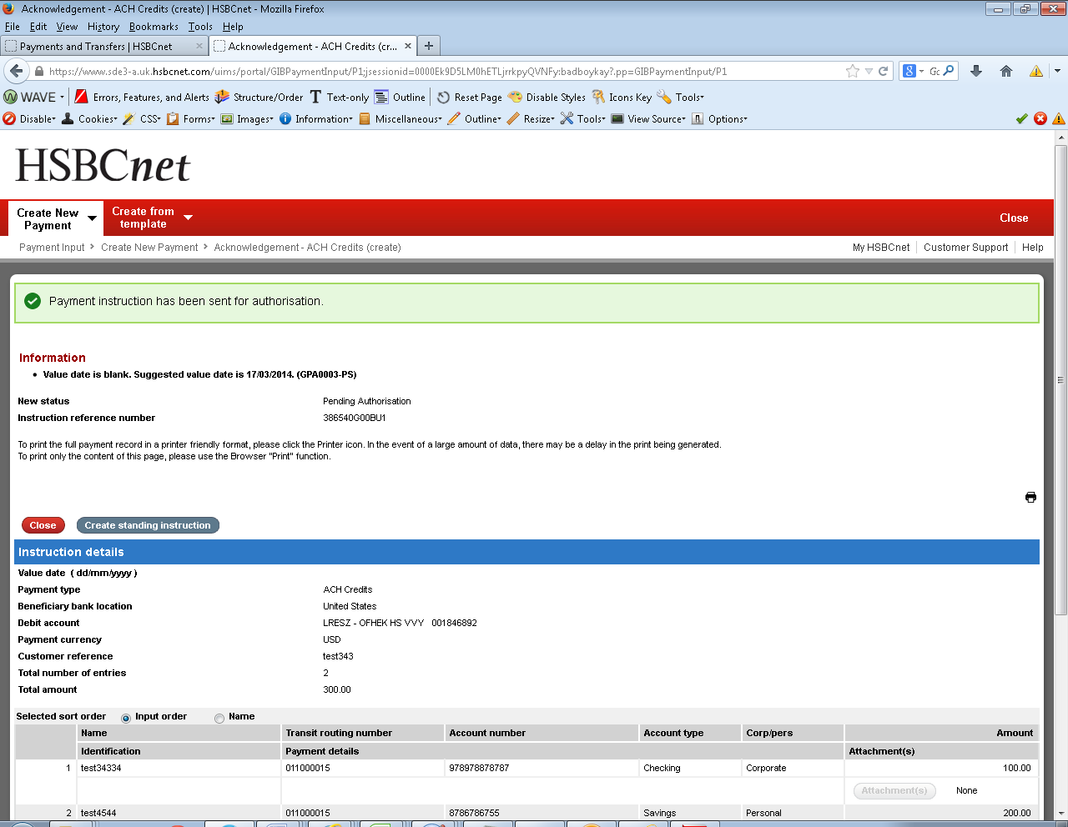 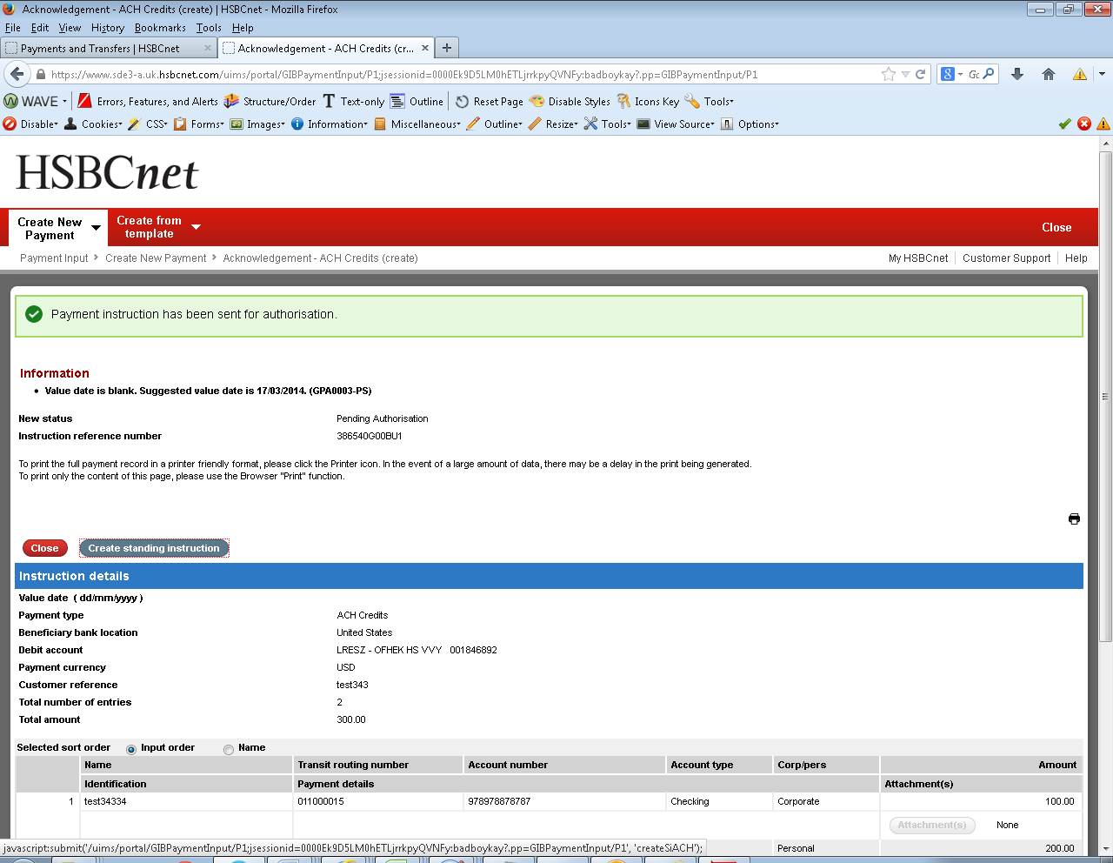 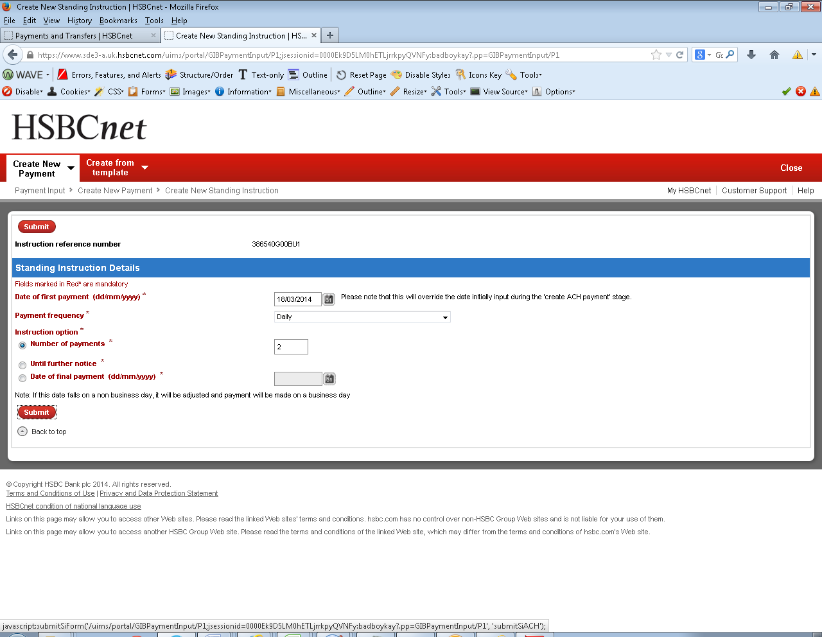 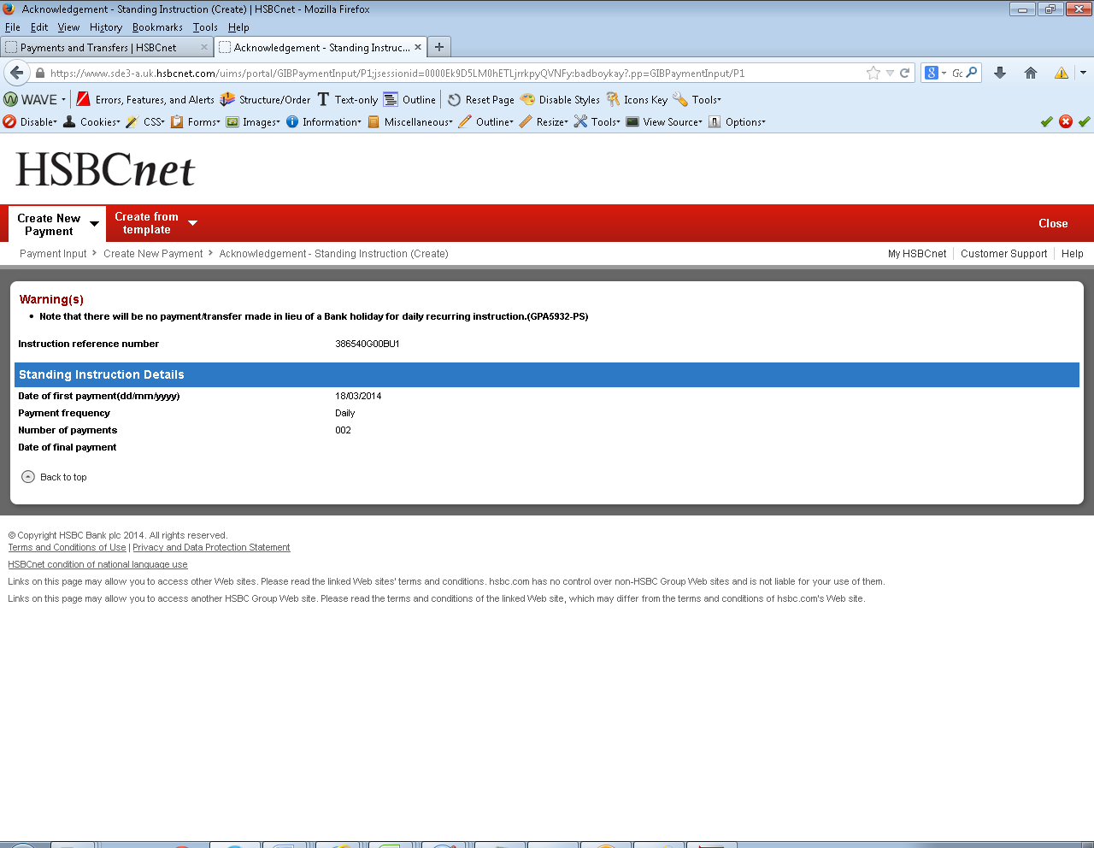

### ACH Debits

* **ACH Debit** instructions involve one credit to the user’s account and debits to multiple payor account.
* Examples ofACH [direct debit](/wiki/Direct_debit?qsrc=3044) transfers are include automatic bill or rent collection.

**Example: ACH Debit instruction**

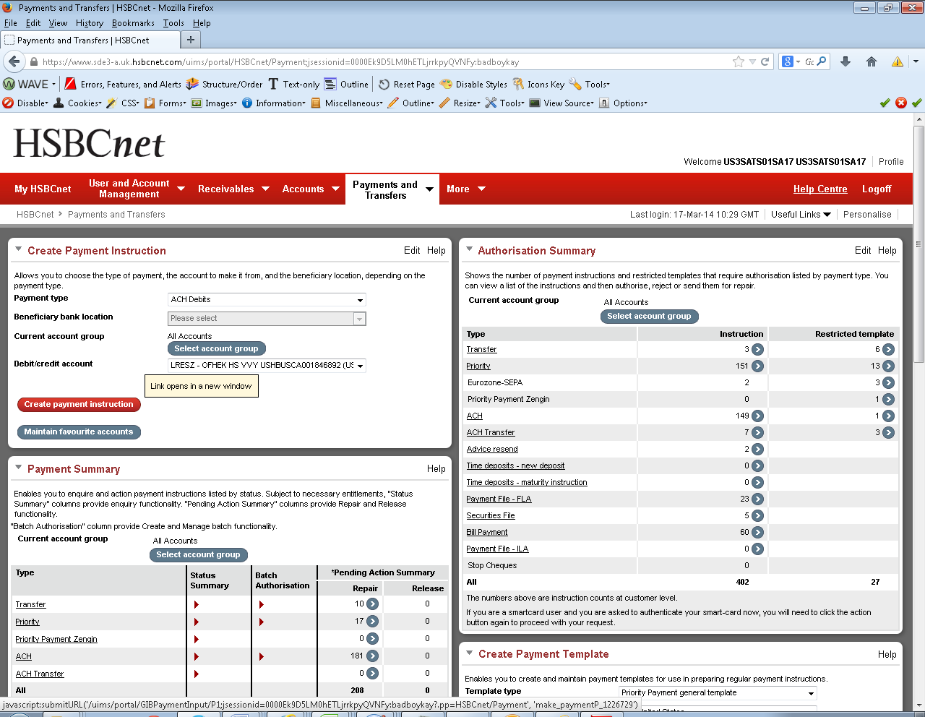

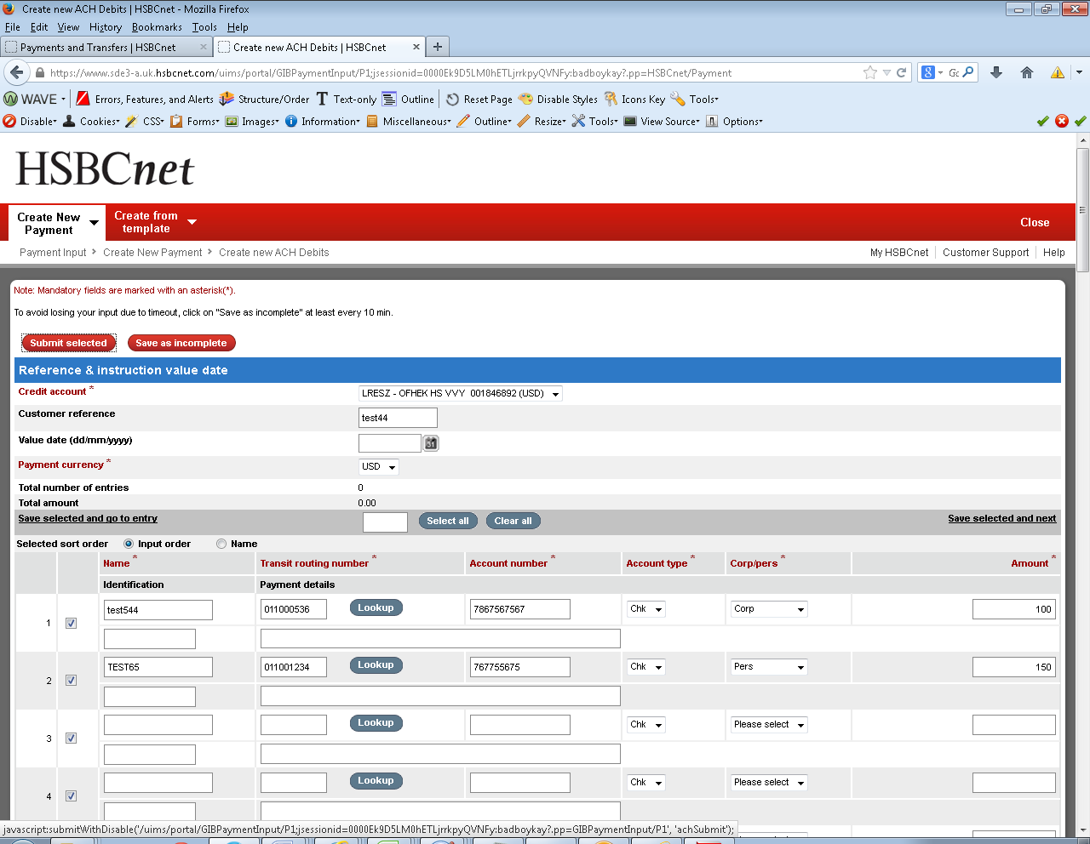 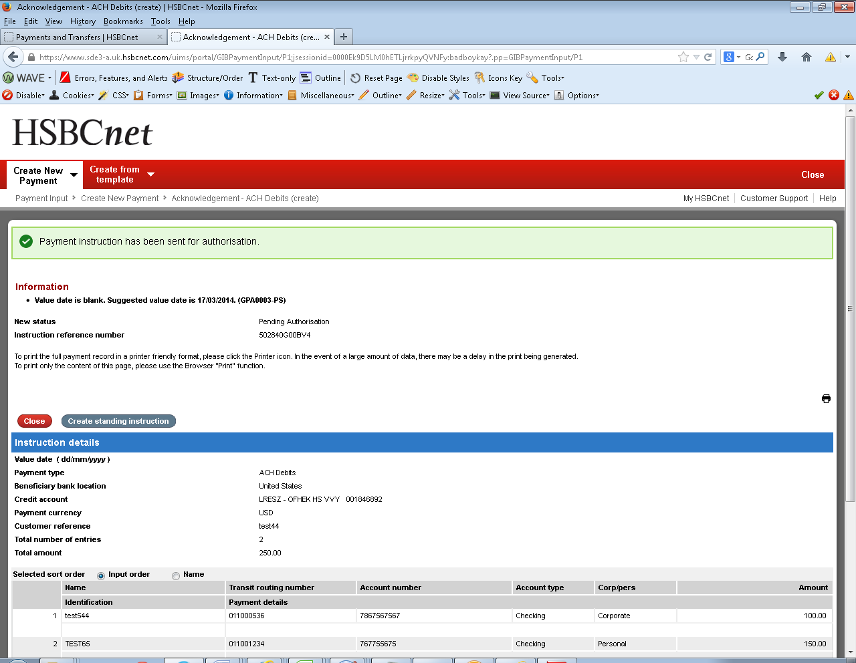

**For standing instruction creation:-**

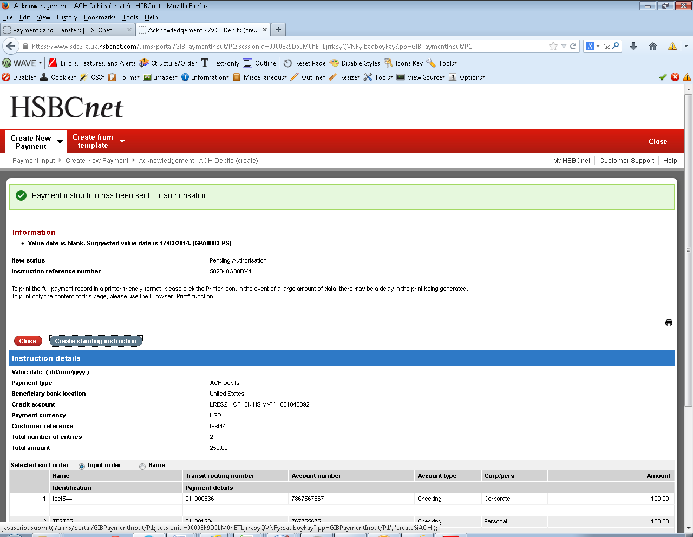 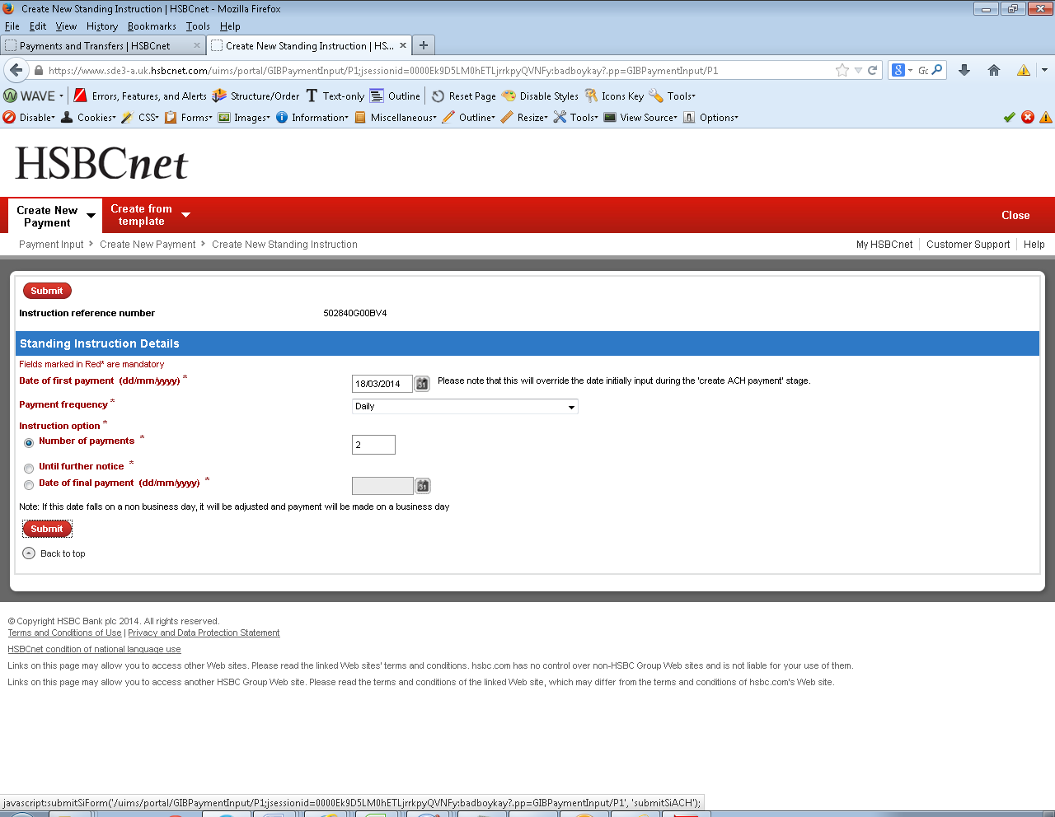 **­­­**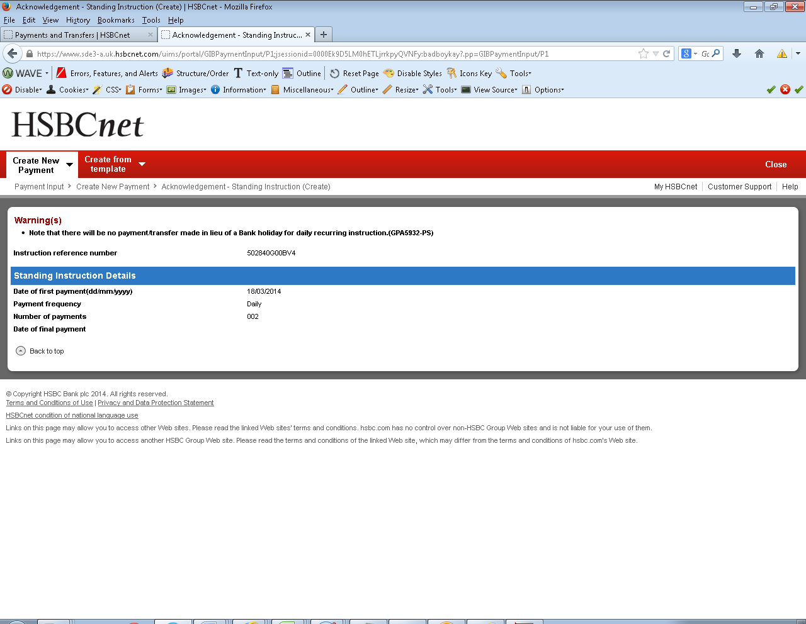

### ACH Transfers Credit

ACH Transfers Credit instruction involves:-

* One debit to the user’s account and multiple credits to the other accounts of the same user within their HSBCnet portfolio of accounts.
* ACH Transfer Credit service is available only to US account holders.
* Examples of an ACH Transfer Credit are transfers from the head office account to branch accounts of a company.

**Example: ACH Transfers Credit instruction**

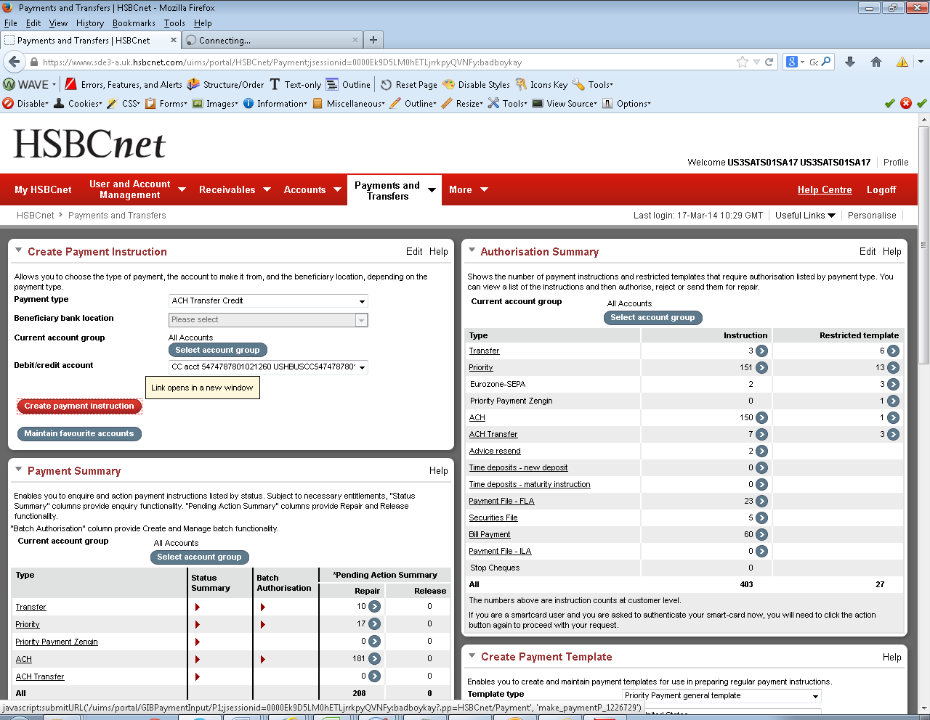

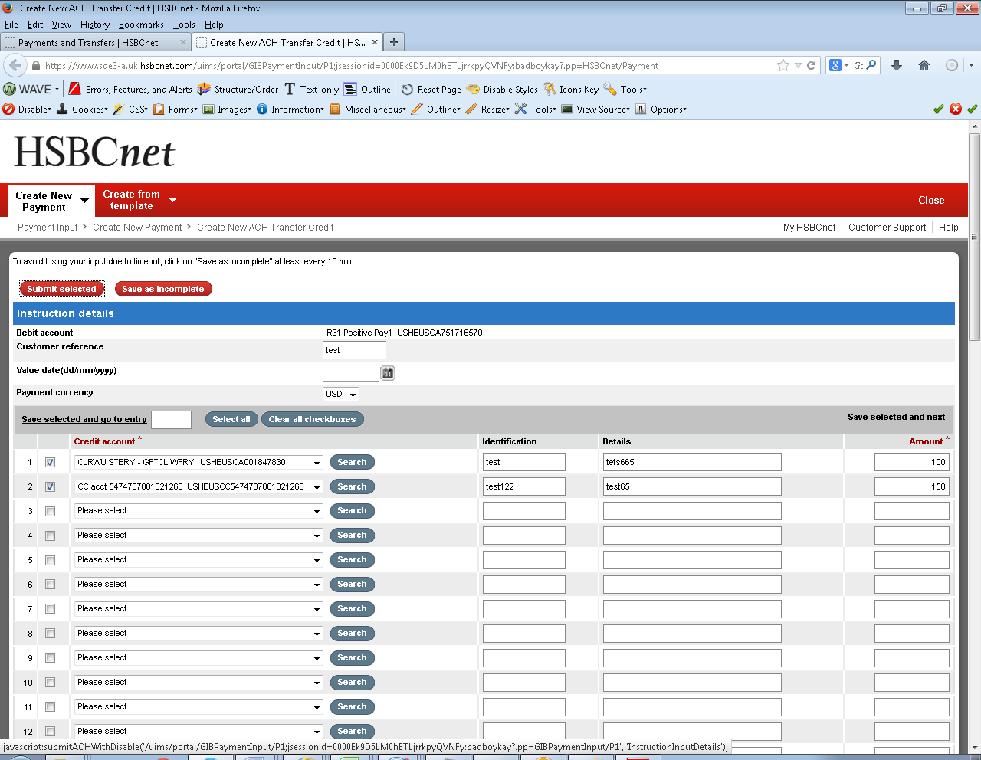 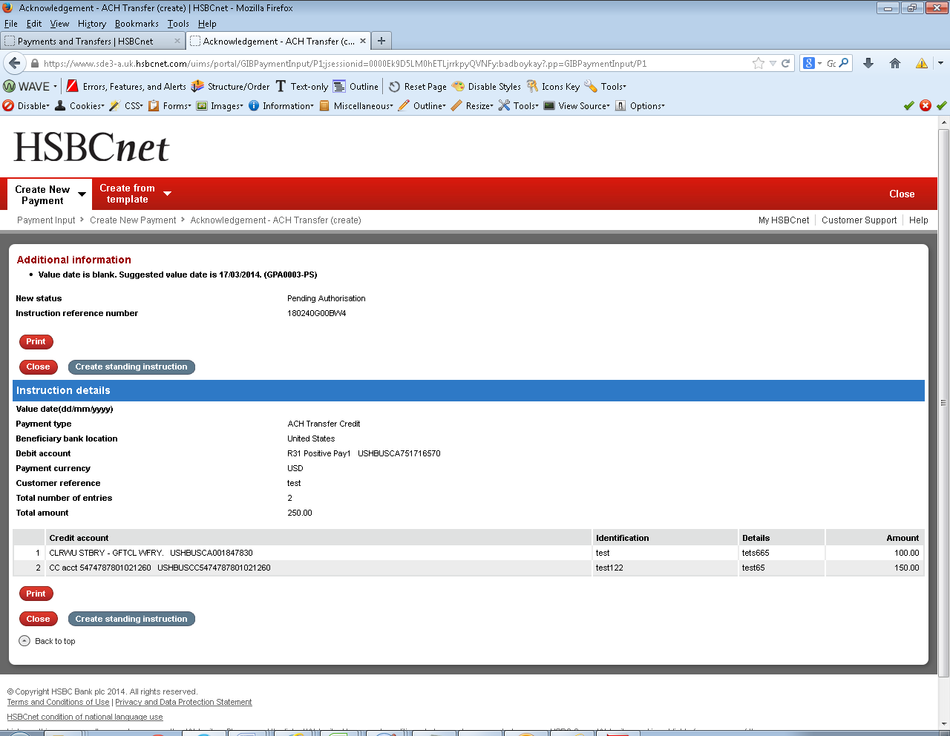

**For standing instruction creation:-**

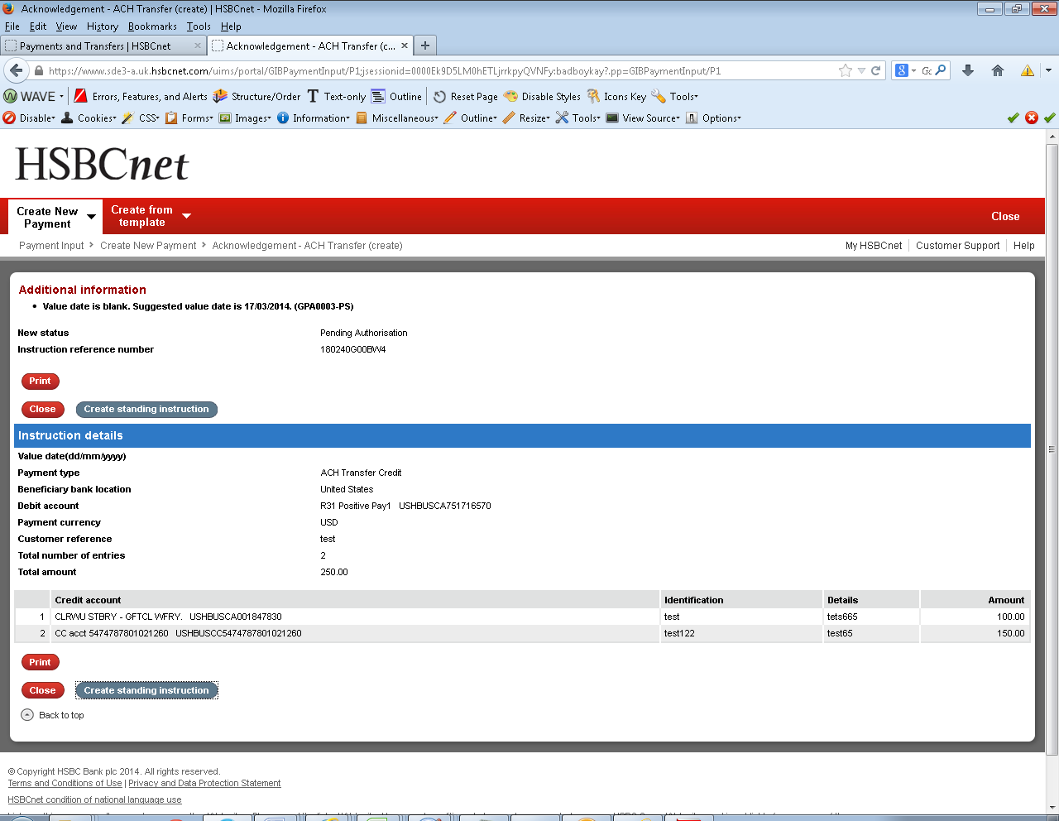 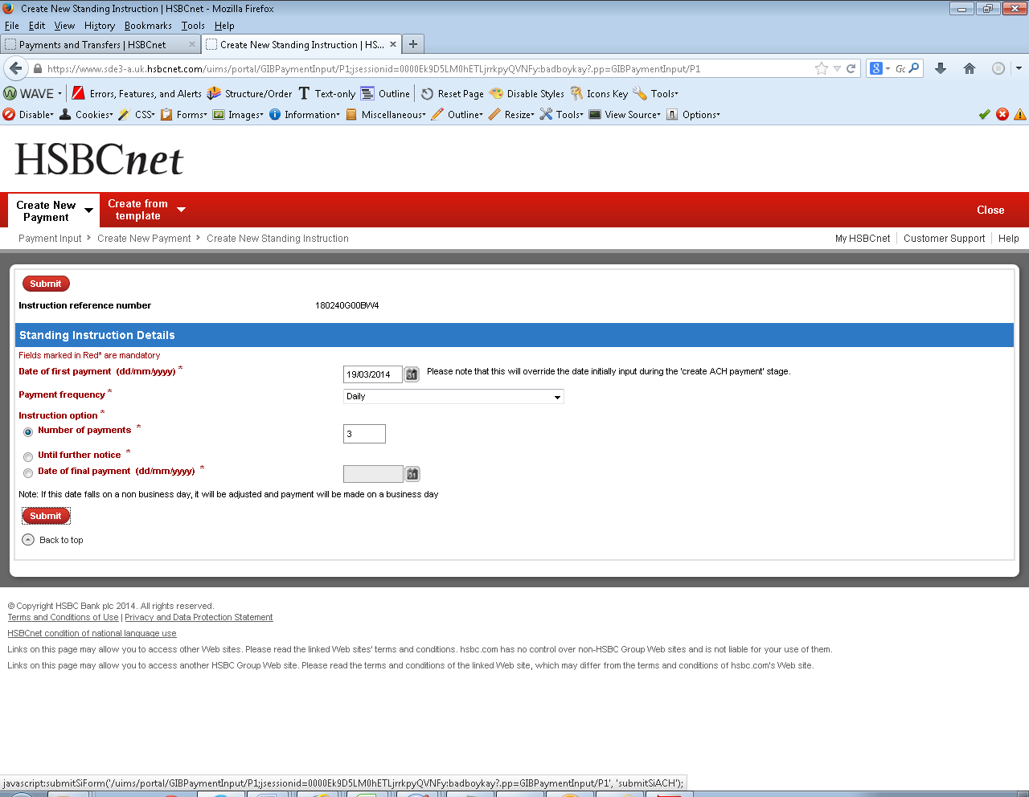 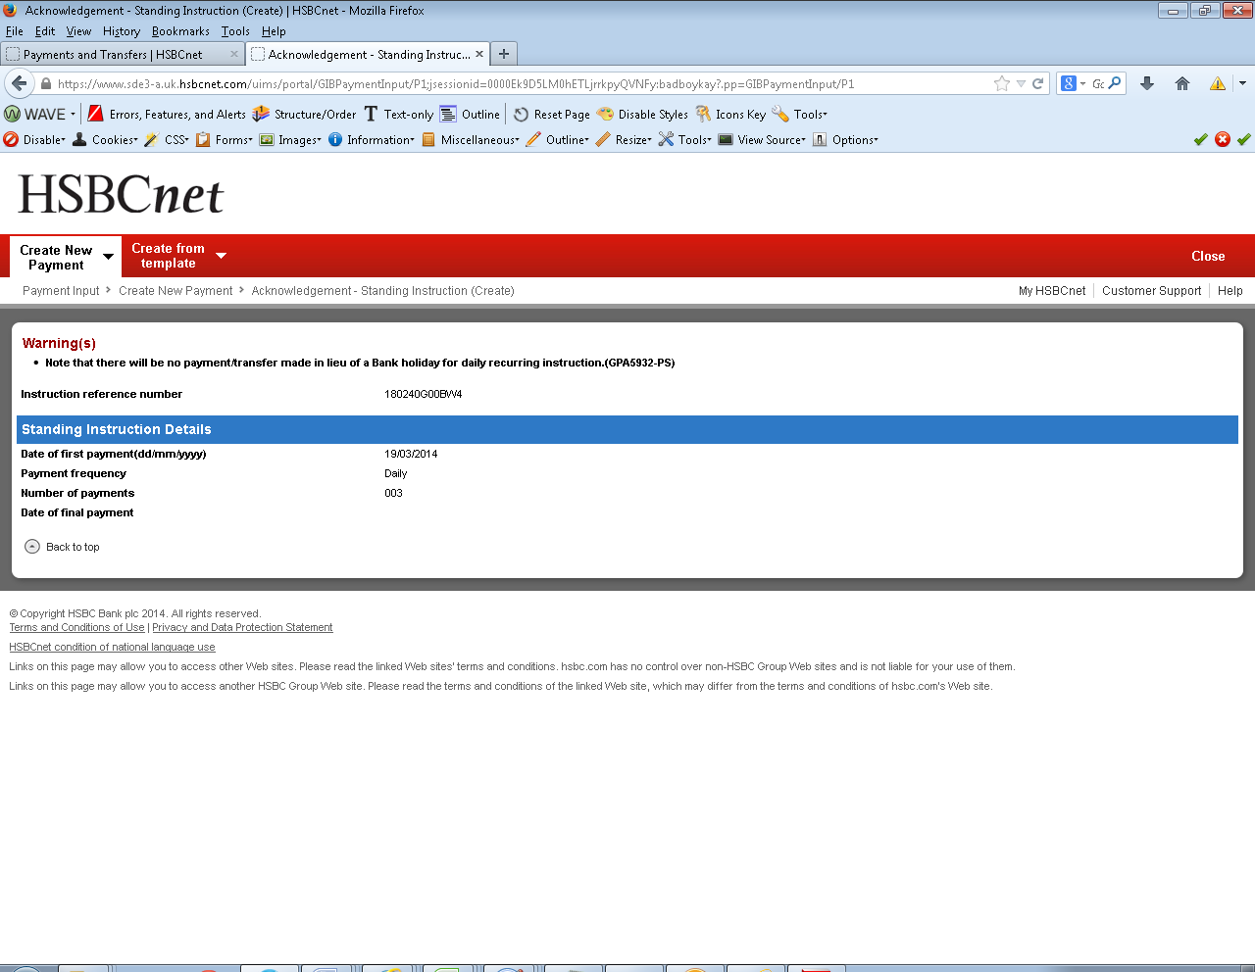

### ACH Transfers Debit

ACH Transfers Debit instructions involves:-

* One credit to the user’s account and multiple debits to the other accounts of the same user within their HSBCnet portfolio of accounts.
* ACH Transfer Debit service is available only to US account holders.
* Examples of an ACH Transfer Debit are transfers from the branch account to head office account of a company.

**Example: ACH Transfers Debit instruction**

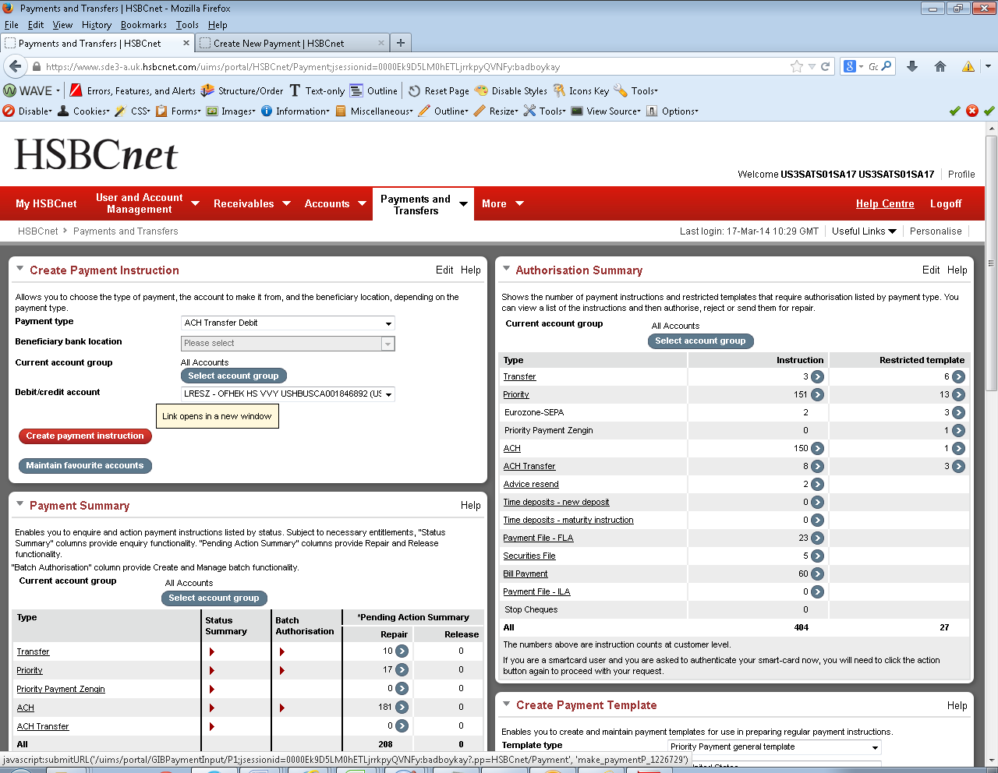 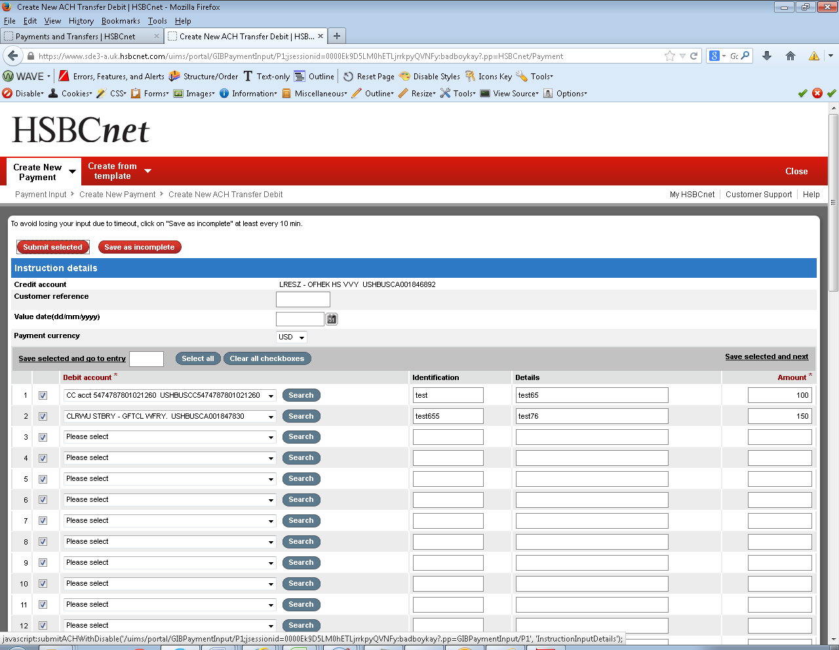 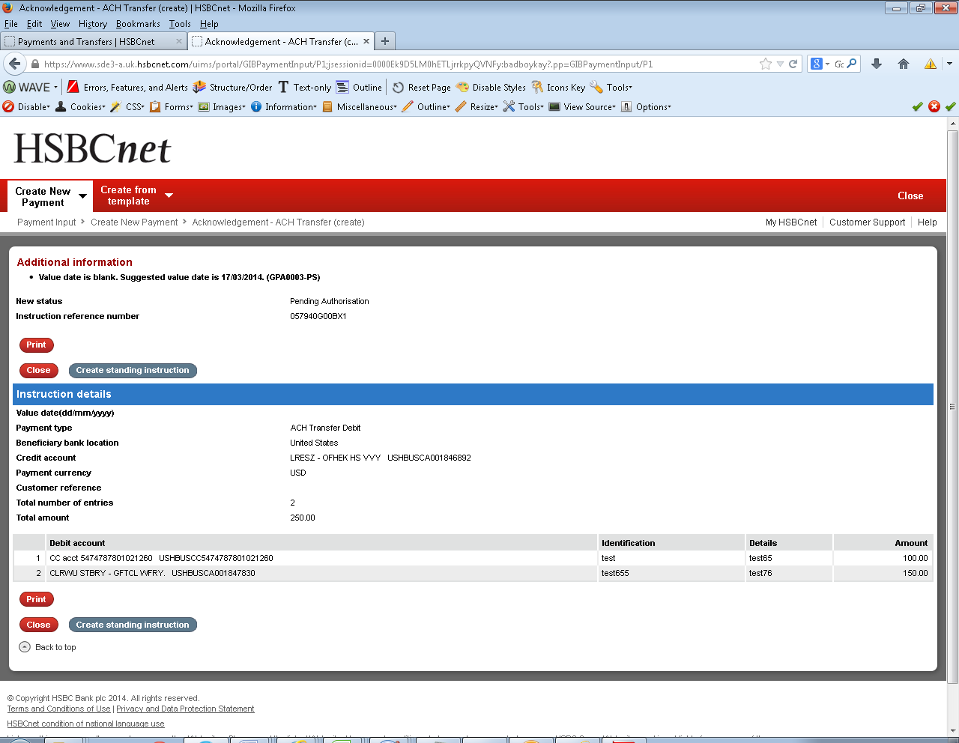

**For standing instruction creation:-**

